PRESS RELEASE
Public Relations Bureau
Bldg. I Fl. 2, Jl. M.I. Ridwan Rais No. 5, Jakarta 10110 Phone: 021-3860371/Fax: 021-3508711
www.kemendag.go.id

Leading the 55th AEM, Trade Minister Zulkifli Hasan Achieves the Completion of 5 ASEAN Economic Priorities
Semarang, 19 August 2023 – The 55th ASEAN Economic Ministers’ (AEM) Meeting succeeded in completing five of the seven economic priorities. The 55th AEM meeting took place on Saturday (19/8) in Semarang, Central Java. The meeting chaired by the Minister of Trade Zulkifli Hasan is part of the series of the 55th AEM Meeting and Related Meetings which will take place 17-22 August 2023.

"As many as five of the seven ASEAN economic priorities were successfully completed at the 55th AEM Meeting. The AEM meeting was the fourth meeting out of a series of 19 meetings of the 55th AEM meeting. The meeting was attended by ASEAN Economic Ministers except Myanmar, the Timor- Leste Minister of Trade and Industry Filipus Nino Pereira, and the ASEAN Secretary General Dr. Kao Kim Hourn," said Trade Minister Zulkifli Hasan.

Trade Minister Zulkifli Hasan explained the five priority achievements, namely the comprehensive completion of the ASEAN Services Facilitation Framework (ASFF), the ratification of studies related to the ASEAN Digital Economy Framework Agreement (DEFA), the signing of the Second Protocol to Amend the ASEAN Australia New Zealand Free Trade Area (AANZFTA) Framework Agreement, the ratification of the Ministerial Declaration regarding the Framework for Project-Based Industry Initiatives in ASEAN, and the ratification of the Terms of Reference (TOR) of the Establishment of Regional Comprehensive Economic Partnership (RCEP) Support Units at the ASEAN Secretariat.

The Minister of Trade Zulkifli Hasan continued, the other two ASEAN economic priority achievements are targeted for completion by the end of 2023. “The two priority achievements are Full implementation of Electronic Certificates of Origin (e-Form D) through the ASEAN Single Window (ASW) and Finalization of Standards Harmonization Road Map to Support Sustainable Development Implementation,” he added.

Meanwhile, in his remarks at the opening of AEM, Trade Minister Zulkifli Hasan revealed that Indonesia's chairmanship in ASEAN was carried out amid a situation full of challenges.

"Through the theme of this year's ASEAN Chairmanship, 'ASEAN Matters: Epicentrum of Growth', we see ASEAN as very important and relevant. ASEAN must also become a center for sustainable economic growth and continue the development of an inclusive regional architecture. We also want to encourage ASEAN to become stronger to be able to respond to various challenges going forward, strengthening unity, and ASEAN centrality," added Trade Minister Zulkifli Hasan.

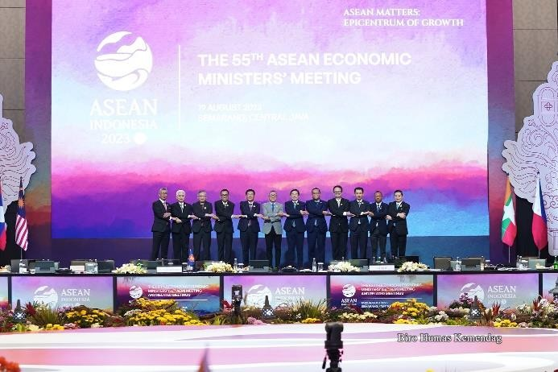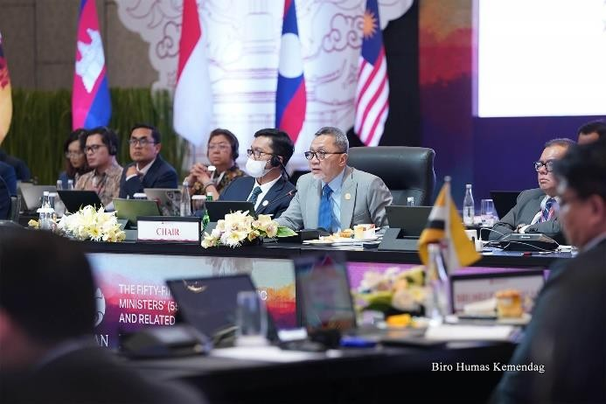
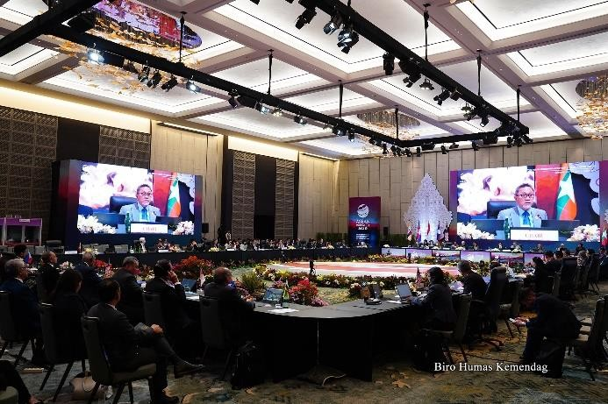
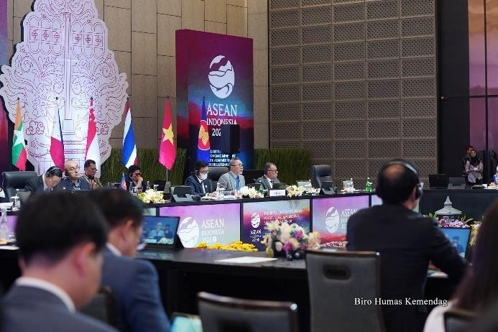

--end--

For further information please contact:  Ani Mulyati  Head of Public Relations Bureau Ministry of Trade  Email: pusathumas@kemendag.go.id | Dina Kurniasari  Director of ASEAN Negotiations  Directorate General of International Trade Negotiations Ministry of Trade  Email: dina.kurniasari@kemendag.go.id

